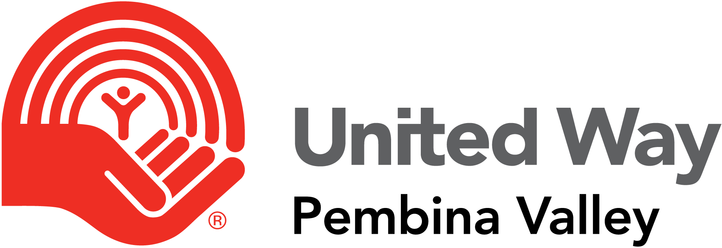

Funding Application
Year 2024
Applications accepted from October 1, 2023 to December 15, 2023

Please download and complete application and send to:
United Way
PO Box 758
Morden MB R6M 1A7

Or email:
unitedwaypembinavalley@gmail.com

United Way Pembina Valley Funding Application
Organization name
Organization mission
Address
Phone number
Email
Website
Charitable registration number
Number of clients
Number of volunteers
Number of paid staff

Note: Please attach a copy of your organization’s latest “audited” financial statement or “review engagement” financial statement.
Contact Information
Name
Address
Phone number
Email

Amount requested
Description of project or program that will be supported
Is this a new program or project?
Number of people supported by the program
Impact of receiving donation
Impact if only partial funding can be provided

Would your organization be willing to allow United Way to publish photos of your program(s) in action (subject to necessary photo releases/permissions)? A United Way staff member will be able to take photos if necessary.
YES |  | NO

- List the programs, including a short description, which your organization currently provides.
Program | Description

- How does your organization evaluate the success of its programs? How often are these evaluations completed?

- Record the number of clients you serve from each of the communities listed.
Winkler |  | Morden |  | Rural Pembina Valley

- How does your organization promote the partnership with the United Way? For example: Display UW logo, social media mentions,

- How does your organization support the United Way?

- Would your organization be willing to provide volunteers to support United Way fundraising events?

This application has been reviewed by the board of the organization.
Name |  | Name
Position |  | Position
Signature |  | Signature
Date |  | Date

